

Analytical Report on Appeals Received by JSC “KDB Bank Uzbekistan” from Individuals and Legal Entities in Q3 2026 and Their Review
This report analyzes the appeals received by JSC “KDB Bank Uzbekistan”, covering current management status, identified negative cases, systemic deficiencies, and specific risks, while outlining proposed measures to address these issues.
Statistical Overview
46  Total appeals  ↑ +9 (+24%) vs. Q2 | 38  Individuals  ↑ 29 in Q2 | 8  Legal entities  → unchanged vs. Q2

- In Q3 2026, a total of 46 appeals were received: 38 applications, 7 complaints, and 1 proposal.
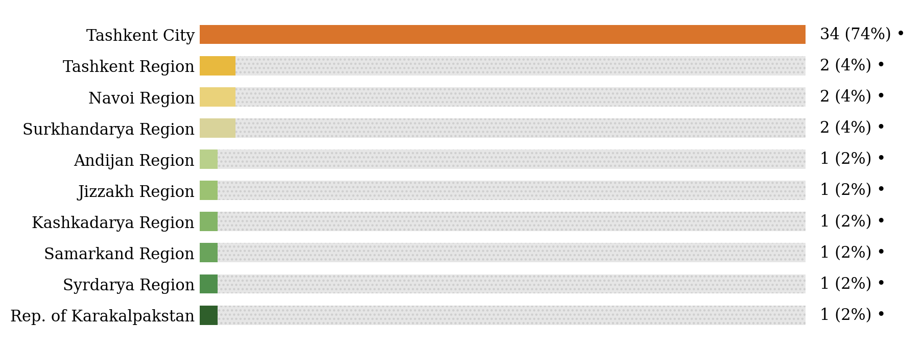

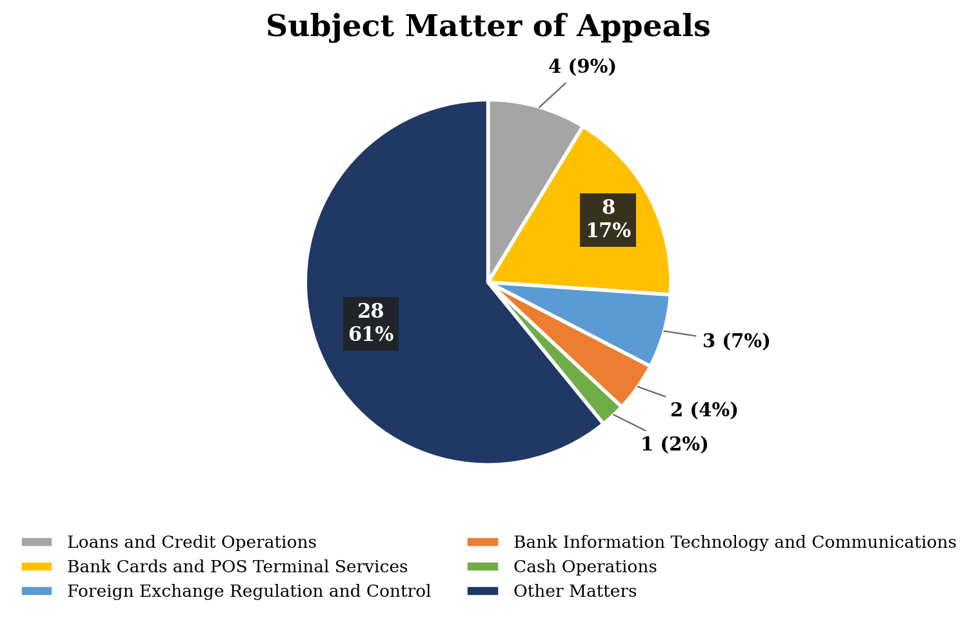

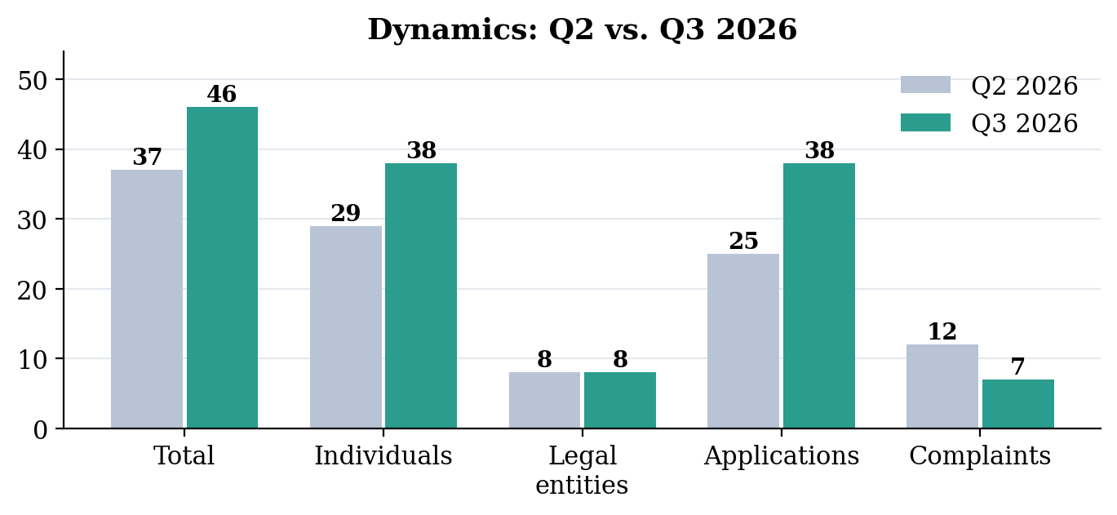

Matters on appeals
Bank has received appeals on various topics, and short comments on their content are shown below.
 | Cash operations — 1  A customer inquired about the exchange procedure for banknotes bearing stamp marks, expressing concern over their validity. |  |  | Bank Cards and POS Terminal Services — 8  These appeals mainly concerned objections related to payment transactions and card services, including mistaken transfers and reimbursement of funds, cash not dispensed by an ATM, unblocking and reissuance of cards, the application of service fees, and a request of a lawyer regarding a client’s card operations.
 | Loans and Credit Operations — 4  Appeals in this category concerned requests to increase a credit limit and to provide working-capital financing (including repeated appeals from one legal entity), as well as requests for clarification of microloan terms. |  |  | Foreign Exchange Regulation & Control — 3  The appeals addressed matters related to foreign economic activity, including the refusal to execute foreign currency payments under foreign trade contracts, the write-off of liabilities under foreign trade contracts and their removal from foreign exchange control in the E-contract system.
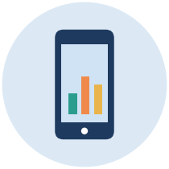 | Bank Information Technology and Communications — 2  The appeals raised concerns regarding the active session time in internet banking and the security restrictions applied in the mobile application. |  |  | Other Matters — 28  The appeals primarily involved requests for information on the existence of bank accounts, deposits, payment cards and loans of a person, including inheritance-related inquiries; information requests of law-enforcement authorities and related matters of bank secrecy; clarifications concerning mobile services and fraud-prevention requirements; a general proposal for the banking sector; as well as other matters of a general nature.
Conformity of Services to Consumer Needs and Fair Treatment
46  Total appeals | 7  Duplicates (15%)

Out of 46 total appeals: 39 (85%) were responded as per established order, while the remaining 7 (15%) were identified as duplicate appeals.

Consideration of Appeals, Systemic Deficiencies and Remedial Measures
In accordance with national legislation requirements, KDB Bank ensures that its services and products are tailored to consumer needs. The Bank establishes transparent and fair relationships with consumers by providing digital public offers and concluding agreements, ensuring that all service processes meet both customer requirements and regulatory standards.
No major deficiencies or violations were identified during the reporting period. All appeals were handled in accordance with established procedures and timeframes.
Following a comprehensive analysis of the matters raised in appeals, the Bank has implemented the following measures:
№ | Measures | Implementation period | Responsible structural units
1 | To ensure the continuous availability of 24/7 card blocking services and the uninterrupted operation of anti-fraud systems. | Ongoing | Bank Cards Department;  Antifraud department;  Client Service Department-2 (including Online Support Part);  Oybek branch.
2 | To revise the Temporary procedure for servicing foreign trade contracts in line with applicable regulatory requirements | The Temporary procedure for servicing foreign trade contracts was revised on 08.07.2026 | Currency Control Department

